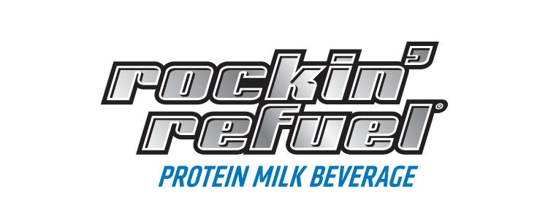

High School Team Rockin’ Refuel® Application

School: _________

School Address: _________

City, State, Zip: _________

Primary Contact: _________

Cell Phone: ____Email: _________

Relation to Team applying (e.g. booster club representative, coach, parent, etc.):

_________

Mailing address for program collateral- if different from school address:

_________

Spring Sport: _______________________ (Circle one): Male Female

Do you expect week long school break during this season? If so when: _____________________

Please check the opportunities below for Rockin’ Refuel to be featured as the team’s official protein recovery beverage (check all that may apply):

- Rockin’ Refuel Van Stop at school/ team game
- Media relations/ opportunities to visit practice
- Program ads
- In game PA announcements
- Banner on field
- Social media posts
- Poster in weight room
- Candid photos of team using product (3-5)
- Product endorsement from head coach
- Other:______________________

We ask that all Team Rockin’ Refuel High Schools make monthly social media posts for the duration of the program. The posts should include photos of the team with product and include #rockinrefuel. Rockin’ Refuel is on Facebook, Twitter, and Instagram. If chosen, would your team agree to these requirements?
- Yes
- No

Please follow Rockin’ Refuel on Facebook, Twitter and Instagram (@rockinrefuel). What are some of the social media outlets we can find your high school program on?
________________________________________________________________________________________________________________________________________________________________________________________________________________________________________________________________________

List three interesting team facts that could be used through Rockin’ Refuel’s social media:
1.
2.
3.

Shamrock Farms Rockin’ Refuel
Team Rockin’ Refuel – Spring 2016

“Team Rockin’ Refuel®” Spring 2016 Sponsorship Program
Official Program Rules
NO PURCHASE NECESSARY

The “Team Rockin’ Refuel®” Sponsorship Program is open only to high school varsity teams at high schools in Metro Phoenix, Arizona. The person submitting the application on behalf of a team must be age 18 or older. Employees of Shamrock Farms®, and their affiliates, subsidiaries, advertising, printing and promotional agencies and members of their respective immediate families are not eligible to submit an application.

Submit your completed application to Christina_Calio@ShamrockFoods.com. Or mail your completed application to: Team Rockin’ Refuel, Attn: Christina Calio, Shamrock Farms Marketing, 2228 N. Black Canyon Hwy, Phoenix, AZ 85009. The Team Rockin’ Refuel application is also available at rockinrefuel.com or can be requested by emailing Christina_Calio@ShamrockFoods.com or by calling 1.888.HI.ROXIE.

Applications must be printed or typed and signed (email signatures acceptable). Applications become the property of Shamrock Farms Rockin’ Refuel (“Sponsor”) and will not be acknowledged or returned. Sponsor is not responsible for lost, late, damaged, postage-due or misdirected mail, or for computer system or phone line errors, software/hardware malfunctions, or other errors, failures or delays in transmissions that are human or technical in nature.

Applications will be accepted beginning at 8:00:00 a.m. January 25, 2016 and all applications must be received by 11:59:59 p.m. February 5, 2016. All applications will be scored by an internal panel of judges whose decisions are final in all matters, based on demonstrated excellence in sport (30 percent), demonstrated usage of Rockin’ Refuel as part of team training (30 percent), level of commitment to program/partnership (20 percent), and team need (20 percent).

The twenty (20) highest scoring teams will be invited to become official members of Shamrock Farms Team Rockin’ Refuel and will receive a flat product sponsorship of Rockin’ Refuel (varieties may vary) valued at $2,300 ARV in exchange for agreeing to feature Rockin’ Refuel as the team’s official recovery beverage (details to be determined by mutual agreement). Winning teams will also be featured on www.rockinrefuel.com. In the event of a tie in the judging process, applications will be evaluated with an “overall impression” score to determine the team that will be invited to become official member of Shamrock Farms Team Rockin’ Refuel.

Acceptance of prize constitutes permission to the sponsor and its agencies to use winner's name and/or likeness for purposes of advertising and trade without further compensation. Sponsor is not responsible for any typographical or other errors in the printing of the offer, administration of the sweepstakes or in the announcement of prizes. By accepting prize, winner agrees to hold Sponsor, its respective directors, officers, employees and assigns, harmless against any and all claims and liability arising out of use or receipt of prize. Prizewinners assume all liability for any injury or damage caused, or claimed to be caused, by participation in this promotion or use or redemption of any prize.

If your team is selected, you will be notified by phone and e-mail on or about February 12, 2016.

Sponsor is not responsible for any typographical or other errors in communications regarding the program, or the administration of the program. Applications become the property of Sponsor and will not be acknowledged or returned.
Sponsor: Shamrock Farms, 2228 N. Black Canyon Hwy., Phoenix, AZ 85009.

